Exercise 3.1. Carpet cost
- Assuming the carpet for the room described in the worked example costs £5.00 per square metre, amend the program to calculate and display the cost of the required amount of carpet.

import java.util.Scanner;
/* Input the length and width of a room in metres, calculate and display the size of carpet needed in square metres */
class carpetCalc
{
public static void main(String[] args)
{
Scanner input = new Scanner(System.in);
double length, width, sizeOfCarpet, costOfCarpet;
System.out.print("Input the length of the room ");
length = input.nextDouble();
System.out.print("Input the width of the room ");
width = input.nextDouble();
sizeOfCarpet = length * width;
costOfCarpet = sizeOfCarpet * 5;
System.out.print("Carpet needed = " + sizeOfCarpet + " sq.m," + " the total cost will be " + "£" + costOfCarpet);
}
}

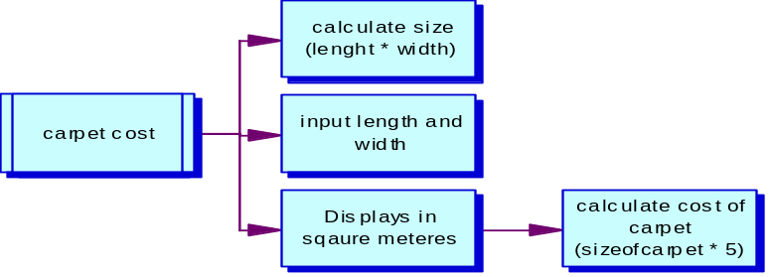

Exercise 3.2. Age in 2050
- Design and build a program to input the year in which you were born and display the age you will be in the year 2050.

import java.util.Scanner;
/* Input your year of birth, this will calculate and display your age in the year '2050' */
class ageCalc
{
public static void main(String[] args)
{
Scanner input = new Scanner(System.in);
double YearOfBirth, Age;
System.out.print("Input your year of birth ");
YearOfBirth = input.nextDouble();
Age = 2050 - YearOfBirth;
System.out.print("Your age will be " + Age + " In the year 2050. ");
}
}

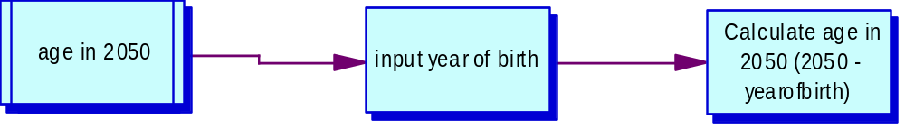

Exercise 3.3. Average
- Design and build a program to input a set of 4 numbers and display their average (be careful with data types!)

import java.util.Scanner;
/* Input 4 numbers and this will calculate the average */
class averageCalc
{
public static void main(String[] args)
{
Scanner input = new Scanner(System.in);
double Num1,Num2,Num3,Num4,YourNum, Average;
System.out.print("Input your first number ");
Num1 = input.nextDouble();
System.out.print("Input your second number ");
Num2 = input.nextDouble();
System.out.print("Input your third number ");
Num3 = input.nextDouble();
System.out.print("Input your fourth number ");
Num4 = input.nextDouble();
YourNum = Num1 + Num2 + Num3 + Num4;
Average = YourNum/4;
System.out.print("The avaerage number is " + Average);
}
}

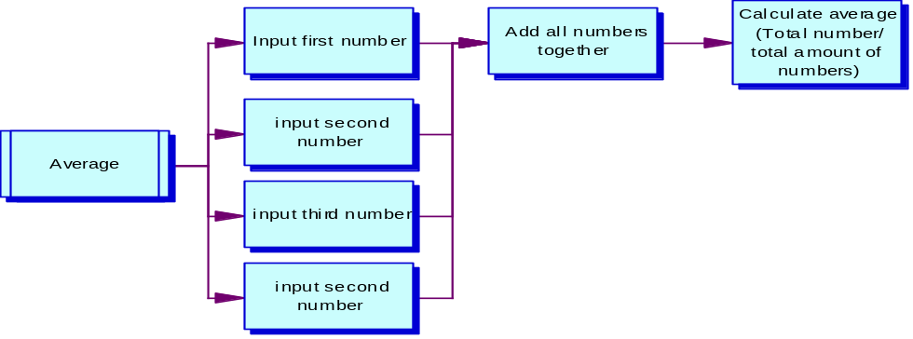

Exercise 3.4. Money
- Design and build a program to input the number of £5, £10 and £20 notes you have, then display the total number of notes and the total amount of money.

import java.util.Scanner;
/* Input the notes you have and this will calcualte the total amount of notes and money you have */
class moneyCalc
{
public static void main(String[] args)
{
Scanner input = new Scanner(System.in);
double p5, p10, p20, MyNotes, TotalNotes, TotalMoney;
System.out.print("How many £5 notes do you have? ");
p5 = input.nextDouble();
System.out.print("How many £10 notes do you have? ");
p10 = input.nextDouble();
System.out.print("How many £20 notes do you have? ");
p20 = input.nextDouble();
TotalNotes = p5 + p10 + p20;
TotalMoney = p5*5 + p10*10 + p20*20;
System.out.print("You have " + TotalNotes + "notes and the totalamount of money you have is " + "£" + TotalMoney);
}
}

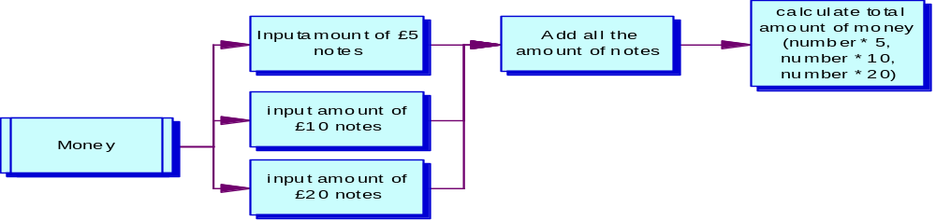

Exercise 4.1. Capital city
- Design, write and test a program which asks the user to input the capital city of France. If they answer Paris, give them a congratulations message.

import java.util.Scanner;
/* This will tell you to enter a city and if you guess the correct city it will tell you */
class cityGuess
{
public static void main(String[] args)
{
Scanner input = new Scanner(System.in);
String paris, city;
System.out.print("Can you guess the French city I am thinking of? ");
System.out.print("Please enter the name of a French city ");
city = input.next();
if (city.equals("paris"))
{
System.out.print("Congratulations!");
}
else
{
System.out.print("Wrong answer!");
System.out.print("Guess again!");
}
}
}

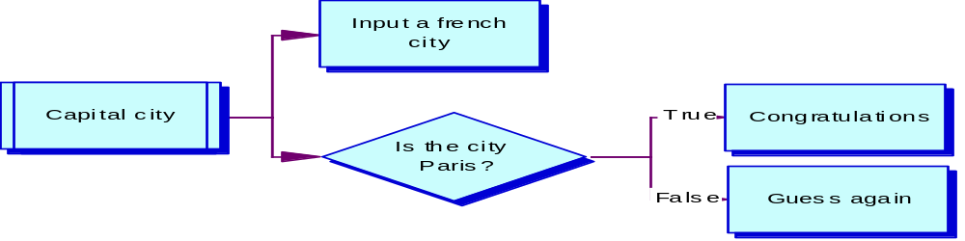

Exercise 4.2. Income and expenditure
- Design, write and test a program which asks the user their income and expenditure, and output 'SPEND SPEND SPEND!", or "Put some money in the bank!" depending on the outcome.

import java.util.Scanner;
/* This will tell you to enter a city and if you guess the correct city it will tell you */
class spend
{
public static void main(String[] args)
{
Scanner input = new Scanner(System.in);
double income, expenditure;
System.out.print("what is your income £");
income = input.nextDouble();
System.out.print("what is your expendicture £");
expenditure = input.nextDouble();
if (income > expenditure)
System.out.print("SPEND SPEND SPEND!");
else
System.out.print("Save your money!");
}
}

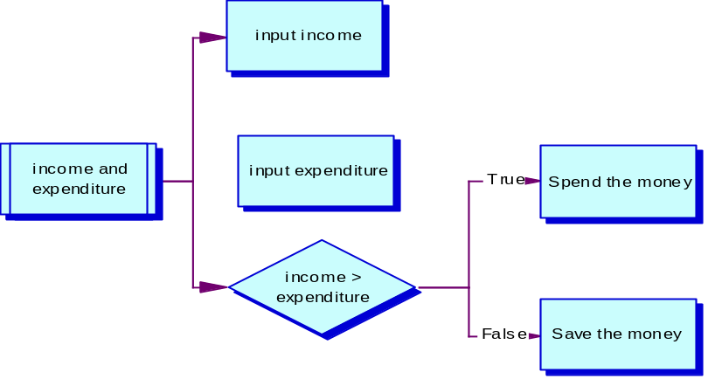

Exercise 4.3. Meal cost
- Design, write and test a program which asks a waiter the cost of a customer's meal. If the cost is 10 pounds or more, give a 5% discount.

import java.util.Scanner;
/* This will calculate discounted price of the meal */
class Discount
{
public static void main(String[] args)
{
Scanner input = new Scanner(System.in);
double mealCost, discount, newmealCost;
System.out.print("what was the cost of the meal? £");
mealCost = input.nextDouble();
if (mealCost > 10)

{
discount = mealCost * 0.05;
newmealCost = mealCost - discount;
System.out.print("Your new total is £" + newmealCost);
}
}
}
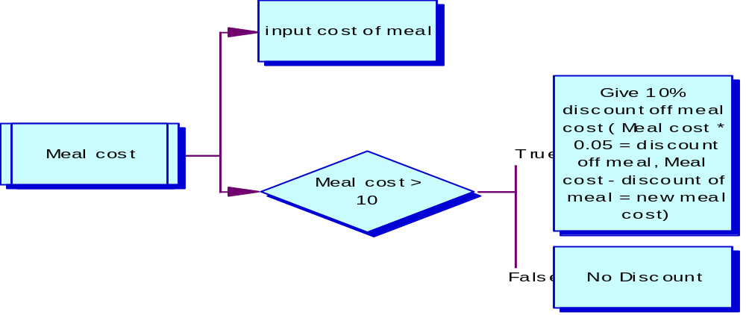

Exercise 4.4. Logic teaser
- Below is a table. Columns 1 and 2 indicate two tests, A and B. As we know, tests always evaluate to true (T) and false (F). The rows of the table indicate combinations of the possible values for A and B. The other columns in the table show more complex tests which use A and B in various combinations along with conditional and logical operators. Fill out the rest of the table for each row, given the True/False values of A and B. To start you off, the first complex condition (A or B) has been completed.

A | B | A||B | A&&B | !(A||B) | !(A&&B) | !A||B | !(!A&&!B) | A||!B
T | T | T | T | F | F | T | T | T
T | F | T | F | F | T | F | T | T
F | T | T | F | F | T | T | T | F
F | F | F | F | T | T | T | F | T

Exercise 4.5. Payday
- Design, code and test a program which inputs a code for the name of a day ("Sun" for Sunday, "Wk" for other Day) together with 2 numbers representing normal hours worked and overtime hours worked. Output the day name and the pay according to the following rules:
Sunday: ordinary hours @ £15 per hour; overtime @ £20 per hour
Other day: ordinary hours @ £8 per hour; overtime @ £12.00 per hour.

import java.util.Scanner;
/* This will calculate how much pay you will recieve for working on a specific day */
class Payday
{
public static void main(String[] args)
{
Scanner input = new Scanner(System.in);
double wage, overTime, overTimePay, normalHours, normalHoursPay;
String day;
System.out.print("Did you work on a Sunday (Sun) or any other day (WK)?");
day = input.next();
System.out.print("How many normal hours did you work? Enter number of hours.");
normalHours = input.nextDouble();
System.out.print("How many overtime hours did you work? Enter number of hours.");
overTime = input.nextDouble();
if (day.equals("Sun"))
{
normalHoursPay = normalHours * 15;
overTimePay = overTime * 20;
wage = normalHoursPay + overTimePay;
System.out.print("Your pay for this day is" + wage);
}
else if (day.equals("WK"))
{
normalHoursPay = normalHours * 8;
overTimePay = overTime * 12;
wage = normalHoursPay + overTimePay;
System.out.print("Your pay for this day is" + wage);
}
}
}

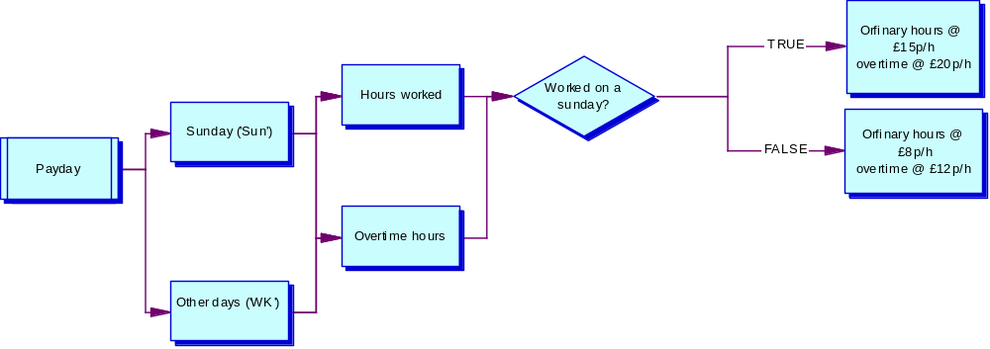

Exercise 4.6. Insurance
- Bike Direct insurance offers bike insurance as follows:
basic rate = £30
add £10 for a mountain bike
add £5 for cyclists under 25.
Design, write and test a program to input the type of bike - mountain or touring, and the cyclist's age, and calculate and display the premium payable.
import java.util.Scanner;
/* This will calculate how much you will pay for insurance */
class Insurance
{
public static void main(String[] args)
{
Scanner input = new Scanner(System.in);
double moutnain, touring, yourAge;
String myBike;
System.out.print("Do you have a Touring (T) or Mountain (M) bike?");
myBike = input.next();
System.out.print("What is your age?");
yourAge = input.nextDouble();
if (myBike.equals("T"))
{
if (yourAge >= 25)
System.out.print("Your premium payable is £30");
else
System.out.print("Your premium payable is £35");
}
if (myBike.equals("M"))
{
if (yourAge >= 25)
System.out.print("Your premium payable is £40");
else
System.out.print("Your premium payable is £45");
}

}
}
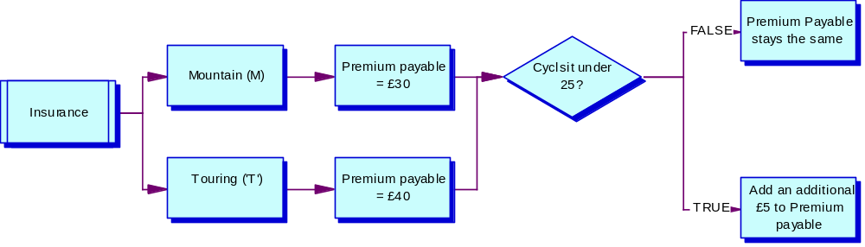

Exercise 5.1. More coffee
- In the coffee survey program, what would happen if nothing, sugar and sweetener were not originally set to zero? Would the program work? - no
- Type in the coffee survey program and get it working. Test to see what happens when only one person likes a particular way of drinking coffee? Modify your program to report in correct English by stating "Only 1 person ... " rather than "1 people ...".
- Modify the coffee survey program to validate the three choices. Trap for out of range values (i.e. where the user types in a number other than 1, 2, or 3). Make sure your program still processes 5 valid selections.

import java.util.Scanner;

class CoffeeSurvey

{

public static void main(String[] args)

{

Scanner input = new Scanner(System.in);

int person, preference, nothing, sugar, sweetner;

nothing = sugar = sweetner = 0;

for (person = 1; person <=5; person++)

{

System.out.println("How do you take coffee?");

System.out.println("1. I don't");

System.out.println("2. With sugar?");

System.out.println("3. With sweetener?");

preference = input.nextInt();

if (preference == 1)

nothing++;

else if (preference == 2)

sugar++;

else

sweetner++;

{

if (sweetner == 1)

System.out.println(sweetner + " use sweetner in their coffee");

if (sugar == 1)

System.out.println(sugar + " person use sugar in their coffee");

if (nothing == 1)

System.out.println(nothing + " person don't sweeten");

}

}

System.out.println("Survey report");

System.out.println("===========");

System.out.println(nothing + " people don't sweeten");

System.out.println(sugar + " people use sugar in their coffee");

System.out.println(sweetner + " use sweetner in their coffee");

}

}

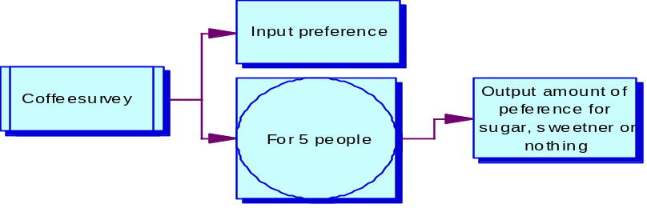

Exercise 5.2. Square and cube
- Design, write, and test a program to input 7 integers and, for each integer, calculate and display its square and cube.
import java.util.Scanner;
/* This will calculate the square and cube of 7 integers */
class squarecube
{
public static void main(String[] args)
{
Scanner input = new Scanner(System.in);
int count;
double square, cube, myNum;

square = 0;
cube = 0;
for (count =1; count <=7; count++)
{
System.out.print("Input a number ");
myNum = input.nextDouble();
square = myNum*myNum;
cube = myNum*myNum*myNum;
System.out.print("Squared = " + square);
System.out.print("Cubed = " + cube);
}
}
}

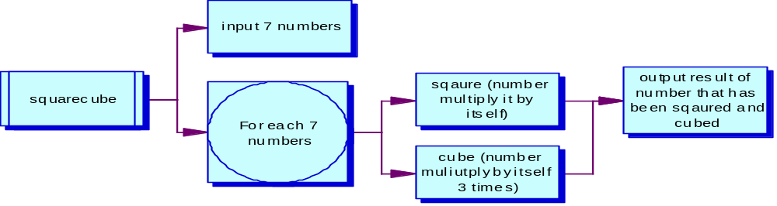

Exercise 5.3. Payslips
- Design, write, and test a program to input 5 pairs of numbers, the first number representing hours worked and the second number representing rate of pay per hour for each of 5 workers. For each worker, calculate and output the gross pay earned.
import java.util.Scanner;
/* This will calculate the gross pay of 5 workers */
class payslip
{
public static void main(String[] args)
{
Scanner input = new Scanner(System.in);
int count;
double hoursWorked, payPerHour, paySlip;

paySlip = 0;
for (count =1; count <=5; count++)
{
System.out.print("Input number of hours worked ");
hoursWorked = input.nextDouble();
System.out.print("Input pay per hour ");
payPerHour = input.nextDouble();
paySlip = hoursWorked * payPerHour;
System.out.print(" Gross pay earned = " + paySlip);
}
}
}

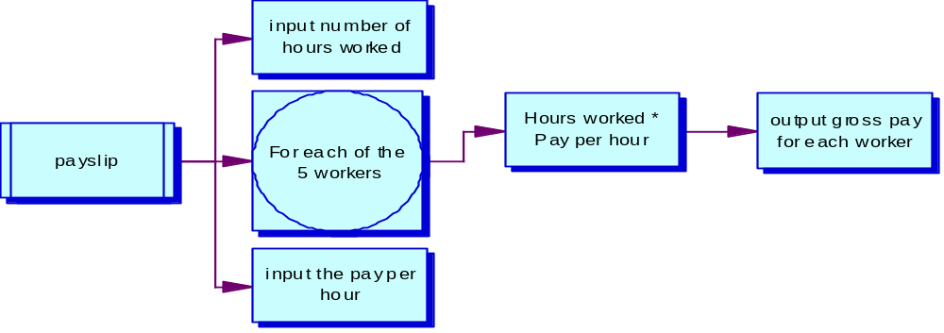

Exercise 5.4. Commission
- Design, write, and test a program to input the commission figures for 10 sales staff; calculate and output the total commission overall and the average commission.
import java.util.Scanner;
/* This will calculate total and average commission */
class commission
{
public static void main(String[] args)
{
Scanner input = new Scanner(System.in);
double comission, total;
int count;

total = 0;
for (count = 1; count <=10; count++)
{
System.out.print("input commission");
commission = input.nextDouble();
total = total + commission;
}

System.out.print("Total sales made £" + total);
System.out.print("average sales £" + (total/10));

}
}
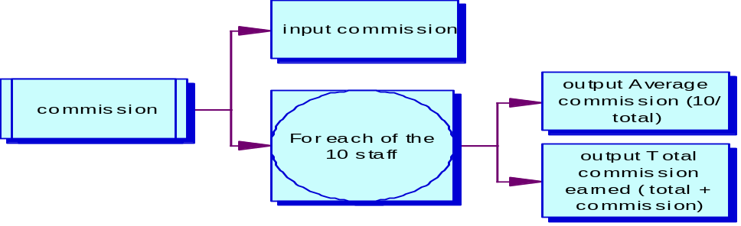

Exercise 5.5. Student marks
- Design, write, and test a program to input the number of students sitting an examination, followed by an exam mark for each of the students. For each student, display the mark and a message 'Pass' or 'Fail', depending on whether the mark is at least 40 (for a Pass) or less than 40 (for a Fail).
import java.util.Scanner;
/* This will calculate whether the student has passed or failed */
class studentmark
{
public static void main(String[] args)
{
Scanner input = new Scanner(System.in);
int count, students, marks ;

System.out.print(" How many students out of 30 have sat the exam? ");
students = input.nextInt();
System.out.print(" What marks did the students recieve out of 100? ");
marks = input.nextInt();

count = 0;
for (count = 1; count <=30; count++ )
{
if (marks < 40)
System.out.print(" The result is a: FAIL ");
else
System.out.print(" The result is a: PASS ");

}

}
}
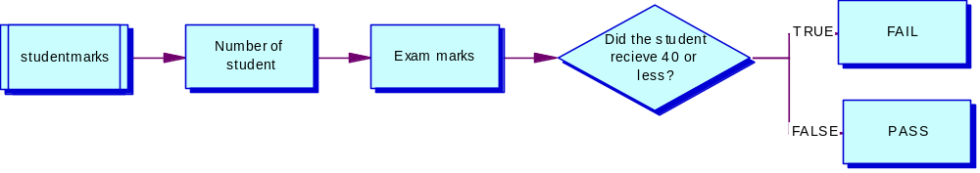

Exercise 5.6. Multiplication table
- Input an integer between 1 and 100 and output the multiplication table for that integer
(i.e. 1 X integer = ?
2 X integer = ?
....
12 X integer = ?).

import java.util.Scanner;
/* This will calculate the Timestbale of a given interger */
class timestable
{
public static void main(String[] args)
{
Scanner input = new Scanner(System.in);
double myNum, num ;
System.out.print(" Please enter a number between 1 and 100 to find out multiplation table. ");
myNum = input.nextDouble();
for ( num = 1 ; num <= 12 ; num++ )
System.out.print(myNum + "x" + num +" = "+ (myNum*num));
}
}

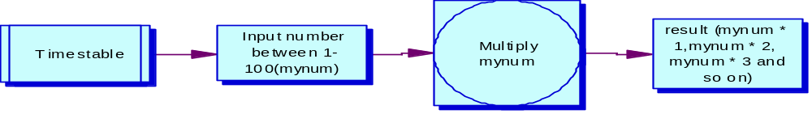

Exercise 5.7. Even more coffee
- Modify your coffee survey program (which used a for loop) to use a while loop instead, as in the example. You may choose to open your original program and save it with a new name. Remember to modify the class name too though!
- A new requirement for the program is to output the number of people surveyed in the report. Use a new variable called personCount to do this, which you should update every time you run through the loop.

import java.util.Scanner;

class MoreCoffeeSurvey

{

public static void main(String[] args)

{

Scanner input = new Scanner(System.in);

int preference, nothing, sugar, sweetner, personCount;

nothing = sugar = sweetner = 0;

personCount = 0;

System.out.println("How do you take coffee?");

System.out.println("1. I don't");

System.out.println("2. With sugar?");

System.out.println("3. With sweetener?");

System.out.println("4. Quit");

preference = input.nextInt();

while (preference !=4)

{

if (preference == 1)

nothing++;

else if (preference == 2)

sugar++;

else

sweetner++;

System.out.println("How do you take coffee?");

System.out.println("1. I don't");

System.out.println("2. With sugar?");

System.out.println("3. With sweetener?");

System.out.println("4. Quit");

preference = input.nextInt();

if (preference == preference)

personCount++;

}

System.out.println("Survey report");

System.out.println("===========");

System.out.println(nothing + " people don't sweeten");

System.out.println(sugar + " people use sugar in their coffee");

System.out.println(sweetner + " use sweetner in their coffee");

System.out.println(personCount + " number of people were surveyed");

}

}

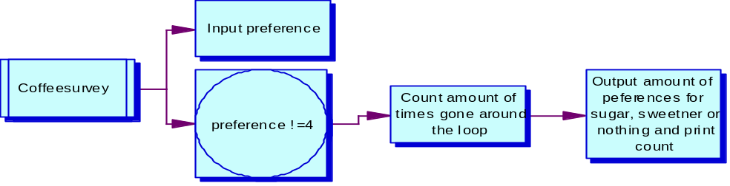

Exercise 5.8. Does not exist!

Exercise 5.9. More student marks
- Design, write and test a program to input student marks in a test. Output 'Pass' if the mark is 40 or above, otherwise output 'Fail'. Input a mark of -1 to finish the program.
- Modify the design and the code of the above program to output the number of students who took the test, the number of passes, the number of fails, and the overall average mark.
- What happens in the above program if there are no students? Make sure your program can cope with zero or more students.

import java.util.Scanner;
/* This will allow the user to input student marks in a test. If the mark is above 40 output 'Pass', else output 'Fail'. input -1 to finish */
class studentMarks
{
public static void main(String[] args)
{
Scanner input = new Scanner(System.in);
int marks;

System.out.print("Input student mark, input -1 when you are finished ");
marks = input.nextInt();

while (marks != -1)
{
if (marks >= 40)
System.out.print("PASS");
else
System.out.print("FAIL");

System.out.print("Input student mark, input -1 when you are finished ");
marks = input.nextInt();

}
}
}

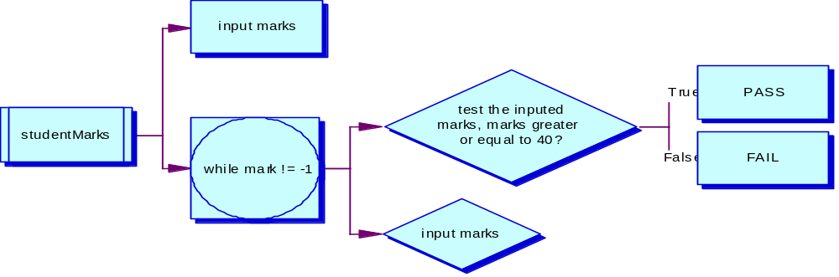

Exercise 5.10. Payroll

- Design, write and test a program to process a payroll. You should input the employee name, their hourly rate, and the number of hours each employee has worked. Output the gross pay and the net pay (with a tax rate of 30%). When there are no more employees, input the word "End", instead of the employee name.

import java.util.Scanner;
/* This will process a payroll for each employee by looking at how many hours they have worked and their hourly rate. It will print out the gross pay and net pay (after 30% tax rate deduction) */
class payroll
{
public static void main(String[] args)
{
Scanner input = new Scanner(System.in);
double hourlyRate, hoursWorked, gross, net ;
String employee;

System.out.print("Please enter the name of the Employee, enter END when you are finished. ");
employee = input.next();

while (!employee.equals("end"))

{
System.out.print("Input the employee's hourly rate ");
hourlyRate = input.nextDouble();
System.out.print("Input how many hours the employee worked ");
hoursWorked = input.nextDouble();
gross = hourlyRate * hoursWorked;
System.out.print(employee + " Earns a Gross pay of £" + gross);
net = gross * 0.30;
System.out.print(employee + " Earns a net pay of £" + (gross - net));
System.out.print(" Please enter the name of the Employee, enter END when you are finished ");
employee = input.next();

}
}
}

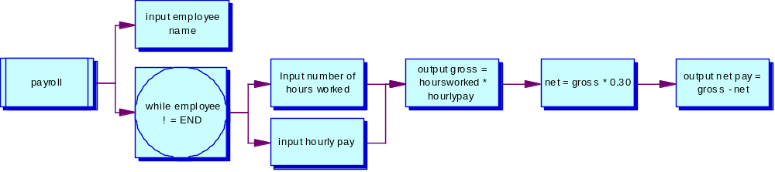

Exercise 5.11. Higher or lower?

- A simple two player game involves player 1 typing in a number, and player 2 guessing the number. Each time player 2 guesses the wrong answer, the computer must reply "Try higher" or "Try lower", to give the player a clue for the next try. When the correct number is guessed, the number of guesses taken will be output, and the program will end. Design and write a program to play the guessing game.

import java.util.Scanner;
/* This is a guessing game, player 1 will input a number and player 2 will have to guess it. player 2 will get clues whether it is higher or lower when guessed incorrectly */
class highlow
{
public static void main(String[] args)
{
Scanner input = new Scanner(System.in);
int count, playerOne, playerTwo;

count = 0;
System.out.print("Player 1 please enter a number ");
playerOne = input.nextInt();

System.out.print("Player 2 please try to guess player 1's number ");
playerTwo = input.nextInt();

while (playerTwo != playerOne)

{
if (playerTwo < playerOne)
System.out.print("higher");
else
System.out.print("lower");

System.out.print("Player 2 please try to guess again ");
playerTwo = input.nextInt();
if (playerTwo == playerTwo)
count++;
}

if (playerTwo == playerOne)
System.out.print("Correct! ");

System.out.print(count + " guesses it took you ");
}
}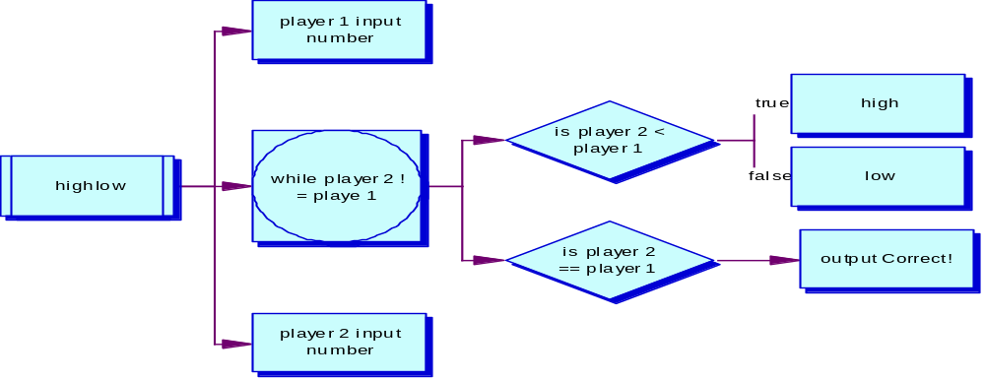

Exercise 5.12. Module marks

- Design, write and test a program to process student module marks. The input data for each student consists of their name, followed by a group of 6 marks for each student (e.g. 56, 45, 75, 32, 68, 39). For each student, calculate the average mark and print a result depending on this average - 'Pass' if at least 40, otherwise 'Fail'. The program finishes when the user types “End” when prompted for the student’s name. Your program should process any number of students.

import java.util.Scanner;
/* This programme will process student module marks. User will input student name followed by group of 6 marks and this will calculate the average, if its greater or eqault to 40 its a pass, else, its a fail*/
class modulemark
{
public static void main(String[] args)
{
Scanner input = new Scanner(System.in);
int markOne,markTwo,markThree,markFour,markFive,markSix;
double averagemark;
String student;

System.out.print(" Please enter student name, type end when you are finished. ");
student = input.next();

while (!student.equals("end"))

{
System.out.print(" input mark 1 ");
markOne = input.nextInt();
System.out.print(" input mark 2 ");
markTwo = input.nextInt();
System.out.print(" input mark 3 ");
markThree = input.nextInt();
System.out.print(" input mark 4 ");
markFour = input.nextInt();
System.out.print(" input mark 5 ");
markFive = input.nextInt();
System.out.print(" input mark 6 ");
markSix = input.nextInt();

averagemark = markOne+markTwo+markThree+markFour+markFive+markSix/6;

if (averagemark >= 40)
System.out.print(student + " average mark = " + averagemark + " PASS ");
else
System.out.print(student + " average mark = " + averagemark + " FAIL ");

System.out.print(" Please enter student name, type end when you are finished ");
student = input.next();
}

}
}

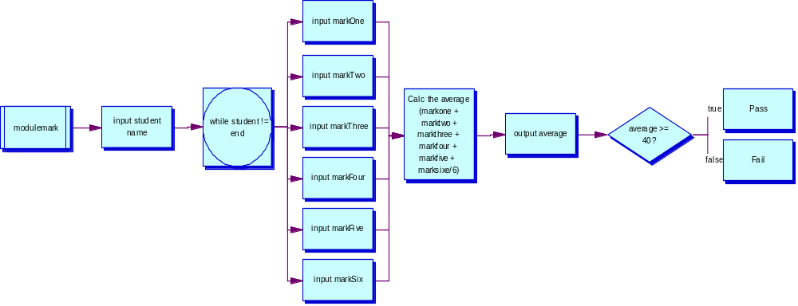

Exercise 6.1. Hello again
- Design, build and test a program that asks the user to input a number, and output the message "Hello world" that number of times. Your program must have a separate method which outputs the set of messages.
import java.util.Scanner;
/* This programme will print out "Hello World" 'n' amount of times the user puts in*/
class helloAgain
{
public static void helloworld(int helloTimes)
{
for (int hello = 1; hello <= helloTimes; hello++)
System.out.print(" Hello world ");
}
public static void main(String[] args)
{
Scanner input = new Scanner(System.in);
int howMany;
{
System.out.print(" How many times? ");
howMany = input.nextInt();
helloworld(howMany);
}

}
}

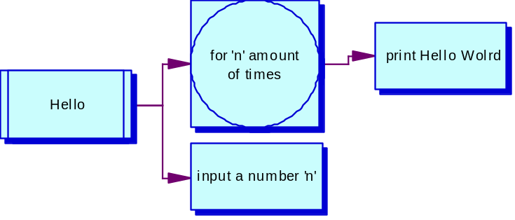

Exercise 6.2. Circle area
- Design, build, and test a program that calculates the area of a circle, based on the user inputting its radius. You must write a separate method to calculate the formula: Area = πr²
import java.util.Scanner;
/* The user will input a radius and this will calculate the area of the circle. */
class circleArea
{
public static double circle (double rad)
{
return (3.141 * rad * rad);
}

public static void main(String[] args)
{
Scanner input = new Scanner(System.in);
double circle, radius;

System.out.print("Input the radius of your circle ");
radius = input.nextDouble();

circle = circle(radius);
System.out.print("the area of your circle = " + circle);

}
}

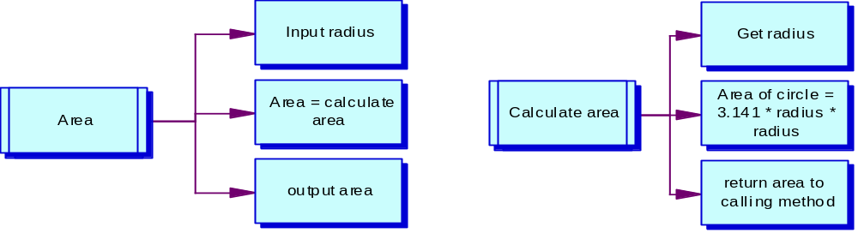

Exercise 6.3. Volume
- Add a new method to your circle area calculation program which calculates the volume of a cylinder with the same base area as the circle. Use the formula: Volume = area * height. Hint: there are lots of ways to solve this problem, but the best way is to use the result returned from the area calculation method as an input to the calculate volume method!
import java.util.Scanner;
/* The user will input a radius and this will calculate the volume of a cylinder. */
class volume
{
public static double circle (double rad)
{
return (3.141 * rad * rad);
}

public static void main(String[] args)
{
Scanner input = new Scanner(System.in);
double volume, height, radius, circle;

System.out.print("Input the radius of your circle ");
radius = input.nextDouble();

circle = circle(radius);
System.out.print("the area of your circle = " + circle);

System.out.print("Input the height of your cylinder ");
height = input.nextDouble();

volume = height*circle;
System.out.print(" The volume of your cylinder is " + volume );

}

}
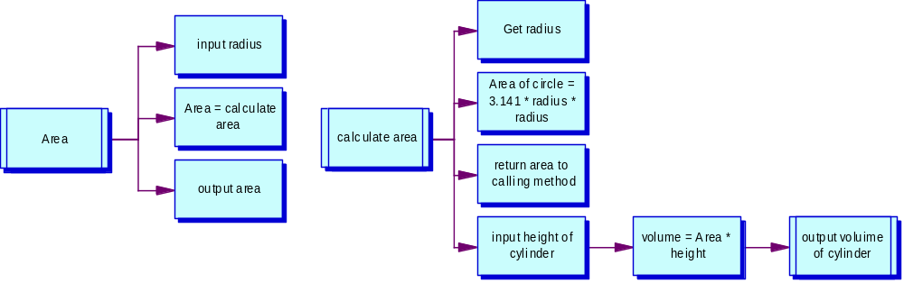

Exercise 6.4. More pay
- Design, build and test a program to input the number of workers followed by their name, hours worked, hourly rate of pay, overtime rate of pay, status (married or single) for each. The main program must use separate methods and appropriate parameters. Suggested methods include:
  - Calculate the gross pay (overtime rate is paid for any number of hours above 40);
  - Calculate the amount of tax paid (25% if Married and 30% if Single);
  - Display all the details as a payslip on the computer screen. Hint: you can pass String parameters too!

Exercise 7.1. Ice skaters
- Design and build a program to enable a user to input an array of six integers, which represent the scores allocated by judges in an ice skating competition. Once all scores have been entered into the array, use it to calculate and output the average score.
- Modify your program to omit the lowest and highest score allocated, taking the middle four marks as the basis on which to calculate the average.
import java.util.Scanner;
/* This programme will allow the user to input 6 intergers that will represent the scores the judges have given, when all the scores are entered it will then work out the average score */
class iceSkate
{
public static void main(String[] args)
{
Scanner input = new Scanner(System.in);
int [] scores = new int[6];
int count;
int total =0;

for (count = 0; count < 6; count++)
{
System.out.print(" Input the score out of 100 " + (count+1));
scores[count] = input.nextInt();

}

for(count =0; count <6; count++)
{
total = total + scores[count];
}
System.out.print(" The average score = " + (total/6));
}
}
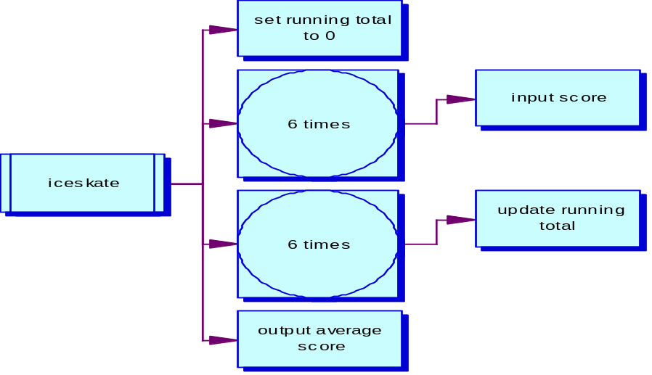

Exercise 7.2. Initialise a list
- Modify the NameList program so that no user input is required to enter the list of names. Instead of the user entering ten names, initialise a new list of names in the String declaration statement.

Exercise 7.3. Saver bonus
- Finally, you will show how you can use arrays to manipulate grouped information. Every Christmas, the Famously Good Building Society awards a bonus to all its savers, expressed as a percentage of the balance of each account. Design, code and test a program to enable a user to type in four savers’ balances and the percentage bonus (which is the same for everyone). The program should then output the new balances for each saver.

Exercise 7.4. Savers with methods
- Modify the Famously Good Building Society program to use methods. Use separate methods for the following functions:
  - enable a user to type in four savers’ balances
  - update the balances by applying the percentage bonus
  - output the new balances for each saver.

Exercise 8.1. Author

- Add a new attribute to the Book class called author. In your main method, after comparing dates, write another test to establish if the author of the two books is the same person.

Exercise 8.2. Music
- Draw a class diagram which describes what you know about three musical instruments. The instruments are piano, guitar, and violin. All of them have strings and all of them make a sound. Pianos have keys and violins have bows. You can strum a guitar and a violin, but you can't strum a piano - you have to hit the keys. Show some other properties and actions that can be performed with the instruments. To structure your class model, use a super class, called Instrument.

Exercise 8.3. Museum
- Draw a class diagram and write the Java code to represent a vehicle museum. Vehicles have a licence plate, a year of manufacture, a value, and a colour. The museum has cars, which have a number of doors, seats, engine type (petrol or diesel), and engine size in litres. The museum also has motorbikes, which have a bike type (sports, tourer, or trails), and engine size in cubic centimetres (cc). Note that you are not expected to run the program – all you need to do is show how the class structures can be coded in Java.

Exercise 8.4. Museum inventory
- Here's a reminder of an exercise from earlier in this chapter: draw a class diagram and write the Java code to represent a vehicle museum. Vehicles have a licence plate, a year of manufacture, a value, and a colour. The museum has cars, which have a number of doors, seats, engine type (petrol or diesel), and engine size in litres. The museum also has motorbikes, which have a bike type (sports, tourer, or trails), and engine size in cubic centimetres (cc).
- Using the knowledge you have gained since tackling this exercise, add the following features to the program in the form of a menu:
  - add new vehicles (bikes or cars)
  - list all vehicles manufactured in a given year
  - list all vehicles of 1 litre or more (1 litre = 1000cc)
  - list all cars
  - list all bikes
    - HINT: for the above two options, you can get a string representation of an object's class by calling the following method getClass().toString(), so to print object x's class, you would do this:
System.out.print( x.getClass().toString() );

